How to use OpenXML4J

# Retrieve and compile sources with Ant

The steps describe here target Windows development environment. We consider that Linux people are smart enough (familiar with these common steps) to reproduce these steps in their own environment.

The OpenXML4J project use Subversion (SVN) as source control software. As a result, to retrieve OpenXML4J sources you must use a SVN client like TortoiseSVN.

## Step 1: Install SVN client

We choose (and use) Tortoise SVN to manage all SVN stuff with the server, but you might use any other software of your choice.

Tortoise SVN is a Free software (under GPL) that add specific items to your contextual menu in the Windows Explorer. You can download and use freely at <http://tortoisesvn.tigris.org> (if you’re a Vista user, be sure to get the 1.3 version at least).

## Step 2: Install Ant

In order to compile, test and package automatically the OpenXML4L library without having to use any IDE or tool, we use Ant (an equivalent to the famous Makefile). You can download Ant at this location: <http://ant.apache.org/manual/install.html>.

## Step 3 : Get the sources

Follow the steps described :

1. Create a directory (called a repository) anywhere on your hard drive, it will store all the project data (sources, documentation, etc).   
   For example *c:\openxml4j* :

[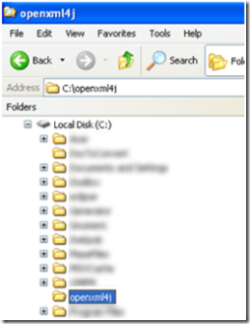](http://archives.chable.net/blogs/images/OpenXML4JRcupreretcompilerlessources_149CC/image5.png)

1. Once you have created your local repository – and installed successfully Tortoise SVN – make a right click of it and select ‘SVN Checkout’:

[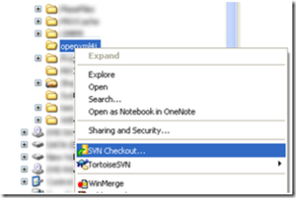](http://archives.chable.net/blogs/images/OpenXML4JRcupreretcompilerlessources_149CC/image10.png)

1. Enter the following URL in the ‘URL of repository’ text box : <https://openxml4j.svn.sourceforge.net/svnroot/openxml4j/trunk>

[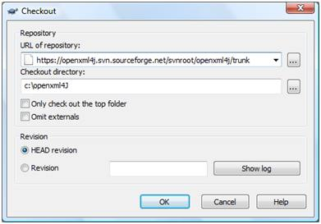](http://archives.chable.net/blogs/images/OpenXML4JRcupreretcompilerlessources_149CC/image15.png)

1. Click on ‘OK’ and let TortoiseSVN make its job (download the full OpenXML4J project repository on the server).
2. That’s it! For more details on the use of Tortoise SVN you can consult the following web page: <http://tortoisesvn.net/support>

## Step 4: Compile sources and package OpenXM4J with Ant

Once you have retrieved the sources, you’ll able to compile and package OpenXML4J with the Ant script provided with the sources (*build.xml* at the root of the *trunk* directory):

1. Make sure that you have correctly configure Ant,
2. Open a shell/console et make sure you are in the *trunk* directory (you know by using the ‘cd’ command ☺).
3. Depending on what you want to do, follow one of the following step:
   1. Only compile sources (not JAR packaging): *ant –f build.xml build*
   2. Compile sources and package the library into a JAR file: *ant –f build.xml dist* (dist is optional as it’s the default target)
   3. Compile and package library (including the sources in a Zip archive) into a JAR file : *ant –f build.xml dist-all*
4. The console should display a similar output in case of success:

[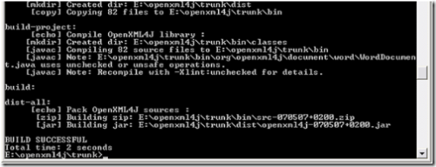](http://archives.chable.net/blogs/images/OpenXML4JRcupreretcompilerlessources_149CC/image20.png)